

Rosanna Cubs – Joint night
with Bundoora Cubs
Tuesday 5th June, 7pm-8:30pm

We’ve started our Cub Pack from nothing and our Cubs have figured it out as they’ve gone along…. Now it’s time to join in with some more Cubs for a night and see what they get up to!

On Tuesday the 5th June, we’ll be meeting with Bundoora Cub Scouts at their Hall – off Noorong Ave, Bundoora (Melway 19 K2) – as per this graphic from www.street-directory.com.au .
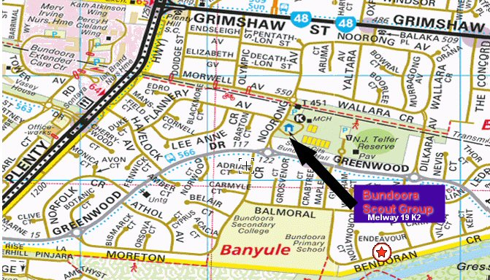

Normal meeting time (7-8:30pm) and full uniform for all Invested Cubs.

This will be a special night, as Bundoora’s Scouts will be running a program based on CSI for us,
so as well as seeing another Cub Pack in action, we’ll get to see the older kids – the Scouts – in action too!

Don’t miss out – see you there (if you have trouble getting there, please talk to Akela (9434 7594) and we’ll see what we can arrange)!

Regards

The Leaders
Rosanna Cub Scouts

See us at http://www.rosannacubs.org

